Orbiter Addons Manager

Welcome to the version 1.0.4a of Orbiter Addons Manager, a useful tool to organize your Orbiter add-ons.

Allows you to install, uninstall, enable and disable add-ons with just one click! Uses an expandable database which supports any add-on, Can create snapshots and import it like a restore point. The new version comes with the support to multiple Orbiter installations, a settings window, a database editor and snapshots feature.

How to use

OAD use is very simple. Open the main program folder, find OrbiterAddonsManager.exe and run it. If this is your first run, the program will look like this.

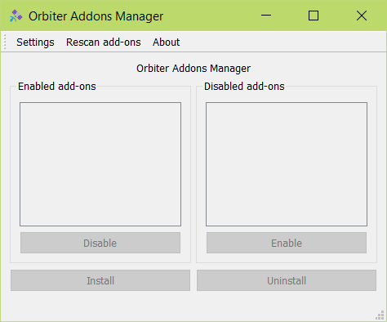

To start working, click on ‘Settings’. The settings window will appear.

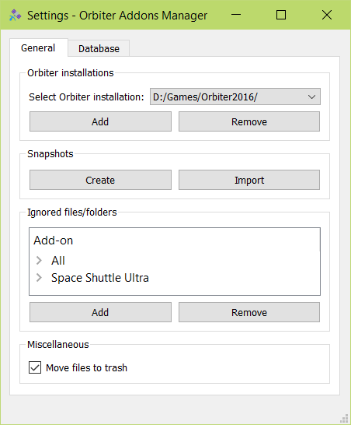

Then click on ‘Add’ button in orbiter installations section. A folder chooser dialog will come into view.

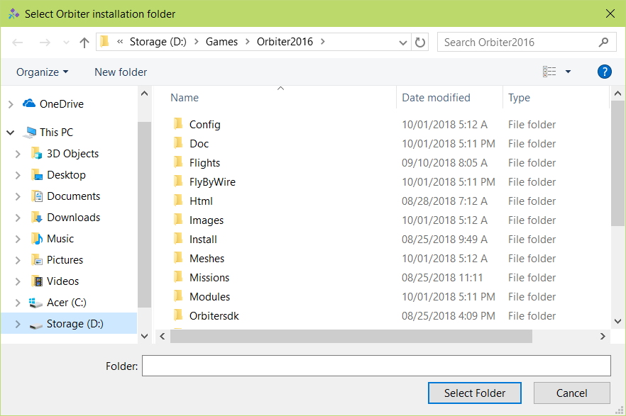

After that, you can see the installation in the installations box. Close the settings window and the main interface will be alive.

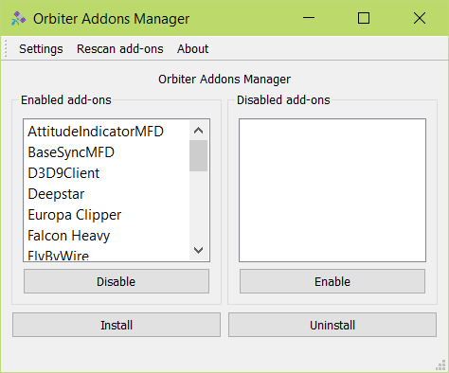

The default database comes with 95 add-ons. If you installed an add-on and it doesn’t appear, you can add it in the database later.

If you want to try the program on a fake Orbiter installation, you must add orbiter.exe in the fake folder. Otherwise, the program won’t accept the folder.

Install an add-on

To install a new add-on, hit ‘Install’ button. The install dialog will appear. Enter the addon name in the first filed.

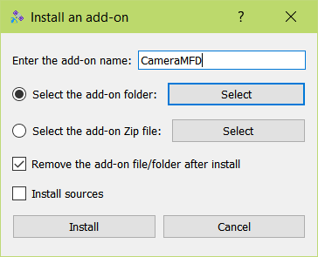

Then you have 2 choices. You may select a folder or a compressed file. Currently, Zip files are supported only. After selecting, hit ‘Select’ button and select the folder/Zip file using file chooser dialog. You’ll notice that a label will appear shows the selected folder/file path.

Check ‘Install sources’ if you want to install the source files (Any file in Orbitersdk and Sources folders).

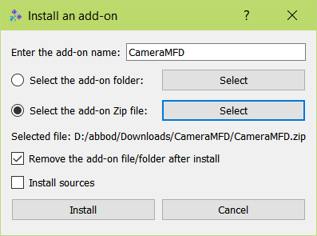

After filling all the fields, hit ‘Install’ button to install the add-on. If everything goes well, you’ll see a message confirms a successful installation.

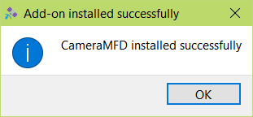

You should see the add-on in the enabled add-ons list.

Enable and disable an add-on

By default, all the add-ons are added to the enabled list. If you want to disable an add-on, simply select it from the list and hit ‘Disable’.

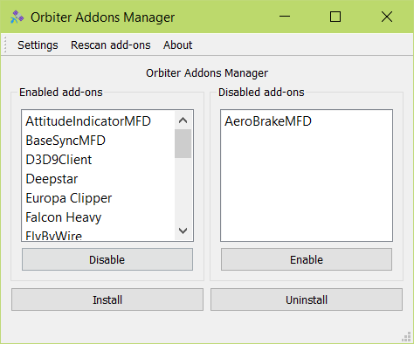

To enable an add-on, select it from the disabled list and hit ‘Enable’.

When you disable an add-on, the program will add ‘.oad’ suffix to it. When enabled, it’ll rename it to its original suffix. The program won’t change any files inside ‘Doc’, ‘Orbitersdk’ and ‘Sources’ folders.

Note that if an add-on has modified the files of another add-on, the program will enable and disable it together. It’ll look like one add-on.

Uninstall an add-on

To uninstall an add-on, select it from the list and click on ‘Uninstall’ button. A confirm message will appear. Hit ‘Yes’ if you want to uninstall it.

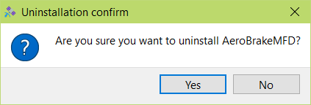

Then you can see a message confirms the add-on is uninstalled correctly without problems.

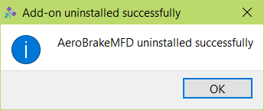

If the add-on requires a modified version of original files, the program will backup it automatically on install and restore it on uninstall. If the backup file doesn’t exist, the program will keep the modified files so you don’t have missing files.

Create a snapshot

Snapshots are something like a ‘picture’ for your Orbiter installation. It contains the file name plus the file size. It’s useful if you want to create a ‘restore point’ for Orbiter installation.

To create a snapshot, open the settings window and click on ‘Create’ button in the snapshots section.

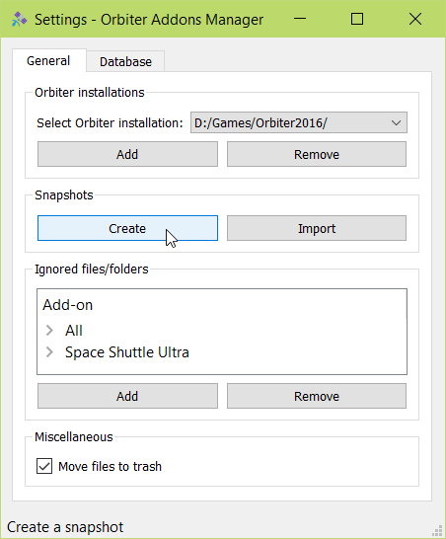

Then you’ll see a message confirms the snapshot:

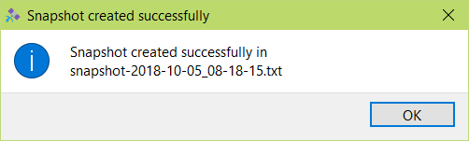

You can find the snapshot file in the program main folder.

Import a snapshot

To import a snapshot, open the settings window and hit ‘Import’ button in the snapshots section. A file chooser dialog will appear. Select the snapshot file and hit ‘Open’.

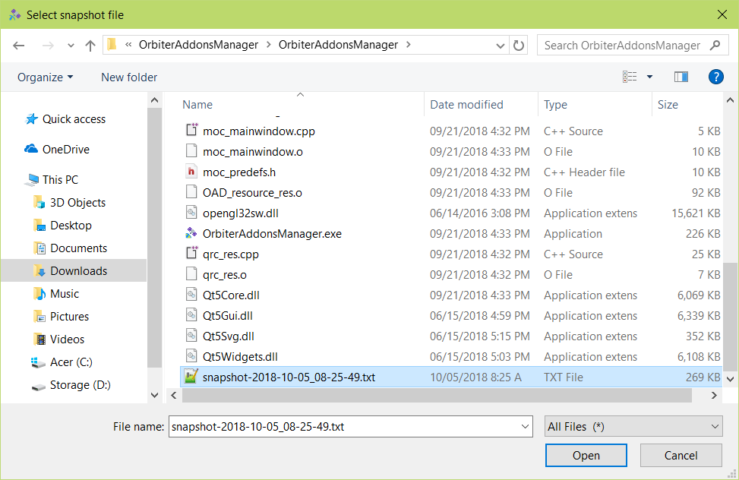

If everything went as expected, you’ll see a successful operation message:

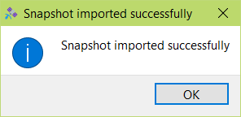

Ignored files and folders

Ignored files and folders are useful in case you didn’t install the full add-on files. For example, you installed the whole add-on but not the ‘Doc’ folder. In this case, you must add ‘Doc’ folder to the ignored list so the program knows the add-on is installed.

To add a one, open the settings window and click on ‘Add’ button in Ignored files/folders section.

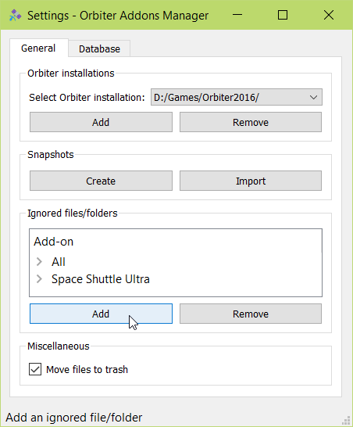

Then a small dialog will request the ignored file/folder. Enter the file/folder and select the add-on, and hit ‘Add’.

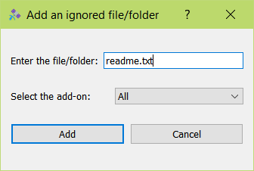

To remove a one, select it from the list and hit ‘Remove’.

‘Move files to trash’ option will move the file to the recycle bin in Windows only. It’ll appear disabled on Mac and Linux. Check it if you want to move files to the recycle bin instead of removing it permanently.

Database editor

Database editor allows you to modify the database. You can add, remove and edit any add-on in the database. It’s useful if you have installed an add-on that doesn’t come with the default database, so you can add it to the database without reinstalling. You have to download the add-on again and use ‘Add’ button to add it to the database.

To add an add-on to the database, open the settings window and switch to Database tab. You can see the add-ons aligned in a tree view.

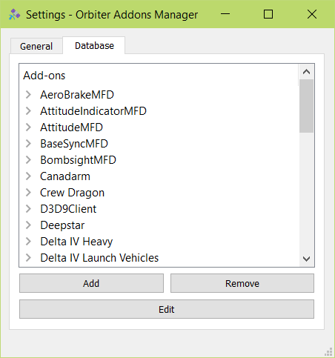

Click on ‘Add’ button. The add dialog will appear. Enter the add-on name.

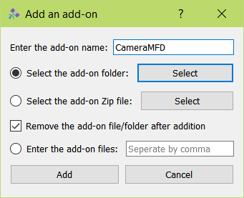

Now you have 3 options. You can select a folder which will be scanned by the program to add the files automatically or select a Zip file which will be scanned also, or enter the files manually.

If you want to select a folder or a Zip file, hit ‘Select’ button. You’ll see a folder chooser dialog. Select the add-on folder/file and hit ‘Select’. You’ll see a text shows the selected folder below. Check ‘Remove after addition’ checkbox if you want to remove the add-on file/folder.

To add the files manually, you must enter it from the view of Orbiter installation. So if the file path is ‘C:\Orbiter2016\File.txt’, you’ll enter ‘File.txt’. If it was ‘C:\Orbiter2016\Doc\Readme.pdf’ then you have to enter ‘Doc\Readme.pdf’. Separate files by a comma “,”.

After that, hit the ‘Add’ button. You should see the add-on in the tree view.

About

Orbiter Addons Manager is a free open-source program, under GPL3 license. You can get the code from the [GitHub repository](https://github.com/abdullah-radwan/OAD). The program was made with C++, Qt 5.11.1 and Quazip using Qt Creator. I hope you’ll enjoy the program as much as I enjoyed while making it.

Should you have any inquiries, don’t hesitate to contact me on [abbodmar@gmail.com](mailto:abbodmar@gmail.com?subject=Orbiter%20Addons%20Manager).

Special thanks to Zan (Zandy12) for testing the program for a long time and discovered a lot of bugs. A big thank you won’t be enough!

Copyright © Abdullah Radwan